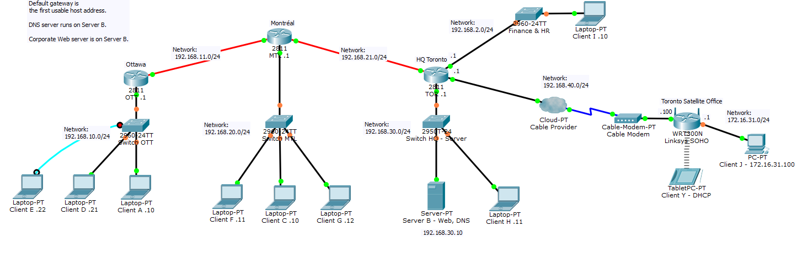

|  |  |  |  |
| --- | --- | --- | --- |
| ***Router*** | ***Description*** | ***Interface*** | ***Address*** |
| OTT | Ottawa LAN | fa0/0 | 192.168.10.1/24 |
| OTT | WAN link to MTL | s0/2/0 | 192.168.11.1/24 |
| MTL | Montréal LAN | fa0/0 | 192.168.20.1/24 |
| MTL | WAN link to OTT | s0/2/0 | 192.168.11.2/24 |
| MTL | WAN link to TOR | s0/3/0 | 192.168.21.1/24 |
| TOR | Server LAN | fa0/0 | 192.168.30.1/24 |
| TOR | Finance and HR LAN | fa0/1 | 192.168.2.1/24 |
| TOR | WAN link to Toronto Satellite Office | fa1/0 | 192.168.40.1/24 |
| TOR | WAN link to MTL | sa0/2/0 | 192.168.21.2/24 |
| WRT300N | WAN Link to HQ Toronto (SOHO) | Internet | 192.168.40.100/24 |
| WRT300N | TOR Satellite Office LAN (SOHO) | LAN (SOHO) | 172.16.31.1/24 |

**WRT300N Settings:**

|  |  |
| --- | --- |
| **SSID** | ACME-WIFI |
| **Network Mode** | Mixed |
| **Security Mode** | WPA2-Personal |
| **Encryption** | AES |
| **Passphrase** | sosecret |
| **Internet IP (WAN)** | 192.168.40.100 |
| **Router IP** | 172.16.31.1 |

**DNS names:**

Client I: clienti.example.com

Server B: serverb.example.com

Client E: cliente.example.com

Client H: clienth.example.com

**Default gateway:**

A LAN’s default gateway is the first usable address on the LAN’s subnet.

**DNS Server:**

The DNS server runs on Server B @ 192.168.30.10